* Run the program, add a few tasks and take a screenshot. Paste that screenshot into your Word document.

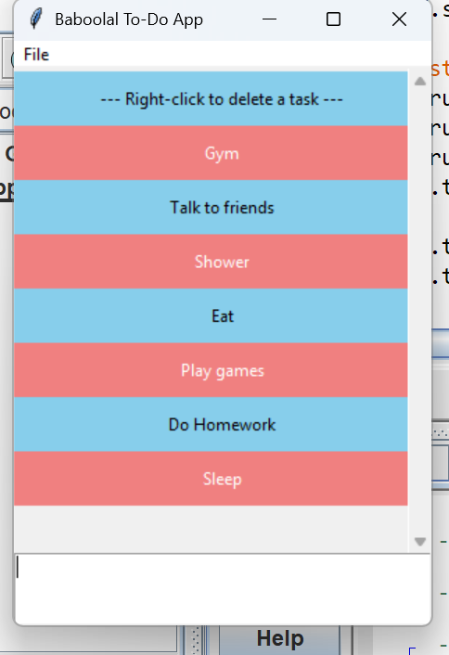

* As the program is running, delete a task, then take a screenshot. Paste that screenshot into your Word document.

